THE STORY – AS TOLD BY THE CUE
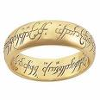
Converting the story of “The One Ring” into a graphic representation that could be conveyed on a cue took a great deal of discussion, time and work. There was an inherent conflict between the great many elements of the story and the need to be concise – to somehow use enough detail of the story without overloading the cue and spoiling the classic beauty of the design. The author, J.R.R. Tolkien, said his story was simply one of good versus evil -- the dark versus the light – frequently symbolized as black versus white. The cue takes this simple approach by juxtaposing the “good” elements of the story above the wrap, looking down on the classic scene of the nine Nazgul being swept away by the “water” horses of the river, mystically summoned by Arwen as she narrowly avoids their capture.

Just as this is a turning point in the story, so it is with the cue. As you turn the cue in your hand and read down through the lines of “The One Ring” poem, it transitions to the darker elements of the story, represented by the evil characters portrayed in the butt sleeve. Finally, the butt cap itself again carries the words of the poem, but this time, in the original elven script. All of this, of course, is accented by the addition of six gold rings, suspended around six of the ivory points. Keeping with the original story, good triumphs over evil as the heroes of the tale peer down over the villains.

The Collaborators

Andy Gilbert, Cue Maker – Andy began making cues in 1989 , and soon established himself as a premier cue builder and designer. With the help of his wife Vickie, he makes a limited number of cues each year at his shop in Clever, Missouri. He is well-known for his traditional, classic designs and discriminating attention to detail. His work is meticulous and virtually flawless. He is also becoming well-recognized for a number of outstanding cues of Native American character and “southwestern ” flavor.

Bob Hergert, Scrimshander – There are scrimshanders, and there are artists. Bob is both. Although he has been doing outstanding scrimshaw art for many years, he is relatively new to cue art. His accomplishments include the “Odalisque” cue for Bill Stroud, “Draco’s Curse” for pfd. Studios, and “Blackfoot Raiding Party”, another Drexler creation now owned by Will Prout. Bob’s reputation as a master scrimshander is well-established because of his well known and meticulous work on knives, jewelry, guitars and other bone and ivory art objects. You can see more of his work at www.scrimshander.com.

Tom Watters, Owner – Tom has been playing pool for many more years than he likes to admit, and collecting cues since the early nineties. He actually began his collection somewhat accidentally, starting with cues by Frank Paradise, Tim Scruggs and Gus Szamboti; all of whom made cues for him as a player. Today, his collection covers the careers of a variety of cue makers, and he likes them all. He continues to try to play pool competitively, and competes when his job lets him. His collection can be viewed at www.recollectioncues.com.

LORD OF THE RINGS
** THE CUE **
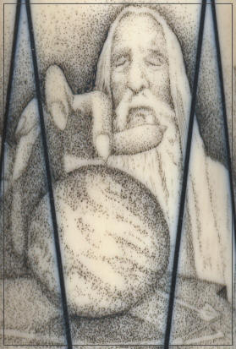

THE FELLOWSHIP OF THE CUE

Just as it required nine collaborators to destroy The One Ring, it required three collaborators to create the Lord of the Rings cue. First conceived by collector Tom Watters, the idea gained momentum at the 2008 International Cue Collectors’ Show in Kansas City, when Tom called an impromptu meeting with master cue-maker Andy Gilbert of Clever, Missouri, and renowned scrimshander Bob Hergert of Port Orford, Oregon. The three agreed to work together with the goal of creating a unique “theme” cue featuring the Lord of the Rings story.

Tom is pleased to introduce this remarkable cue at the 2009 ICCS in Santa Fe, New Mexico.

Background

The Lord of the Rings Cue is inspired by the epic high fantasy trilogy, Lord of the Rings, written by J.R.R. Tolkien. It was originally intended as a sequel to an earlier book, The Hobbit, but eventually was published as a three part novel. The title of the book refers to the magical ring created by the dark lord Sauron as the ultimate weapon in his quest to conquer middle earth. Actually, there were nine rings in all, but “The One Ring” was the most powerful, as it was able to bring the forces of all nine together. In recent years, the books gained even greater popularity when they were made into an academy award winning three-part movie by producer and director Peter Jackson.
Anyone familiar with the trilogy will quickly identify with this cue, and some of the tale’s unique characters – Bilbo and Frodo, the hobbits, Gandalf the wizard, Gimli the dwarf, Legolas the elf, Galadriel, the elven princess, and the true King, Aragorn, a mere human with elven blood. Many villains are included: Saruman, the evil wizard, orcs, oliphants, and of course, Gollum.

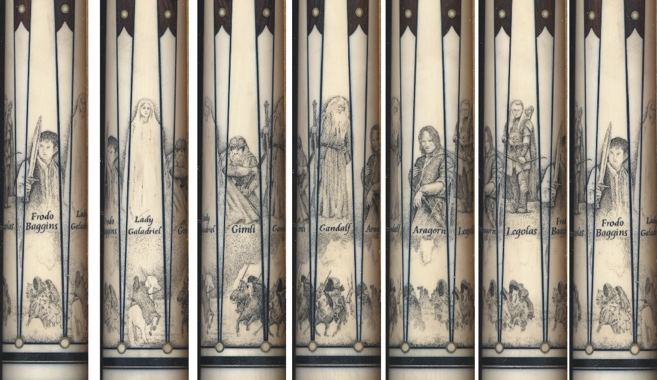

The Cue

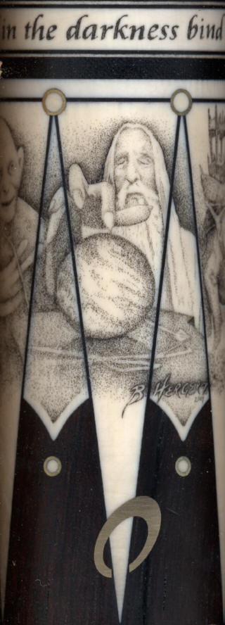
In the months following the ICCS in Kansas City, Tom and Andy talked regularly about the design of the cue. Tom had a vague idea, but he knew from the beginning that he wanted to design a theme cue that was different from others. First, he wanted to get away from the traditional format. Instead of providing the scrimshander with the traditional solid “canvas” provided by an ivory handled cue, he wanted to reverse the design and provide a working surface that would be concentrated in the nose and butt sleeve, not just the handle. Second, he wanted the cue to be a beautiful cue even before it was scrimshawed. Andy suggested a Brazilian Rosewood forearm and butt, and a handle of fine ebony. Keeping with the story line, Tom wanted four ivory rings built into the cue where the four key lines of the classic “Rings” poem could be scrimshawed: One ring to rule them all, one ring to find them, one ring to bring them all, and in the darkness bind them. At Andy’s suggestion, the four rings became part of the ebony handle.

Still, the cue needed at least one more important feature – the gold ring itself, one of the most important features of the entire trilogy. Tom originally conceived of a single ring suspended around one of the points, but it was Andy and Vickie Gilbert’s idea to include not just one, but six floating solid gold rings around six of the twelve points in the cue. Andy melded and forged the gold into beautiful three-dimensional rings and positioned them perfectly. In the end, Andy, with Vickie’s help, built a beautiful cue that could have stood on its own without further ornamentation. However, the story of this cue was still just beginning.

The Scrimshaw

Once in the hands of Bob Hergert, the cue began to take on a life of its own. Tom had a few specific requests, and then wanted to stay out of the artist’s way and let the creative process play out. He asked that the four lines of the poem be scrimshawed into the four handle rings, and that the poem also be engraved either on the butt cap, or the joint, in the original elven script. He had some suggestions about key characters in the book that he thought should be considered for display on the cue, but he had no idea where or how. He left the rest to Bob, and the result is a truly amazing work of art. Discussions became ideas, ideas became sketches, and a plan evolved. Over several months Tom and Bob emailed and talked by phone for many hours. The plan was to separate the elements of good and evil around a key event that would become a turning point in the story. The river scene just above the handle was conceived by Bob to become that event, and the overall design emerged from that concept. This same idea is carried out below the handle, where the famous Oliphant battle scene is recreated among images of the villains of the tale. The result is the masterpiece you see on the cue.

